Name: Varia Neel Jitesh
Enrollment No: 250447003019

Network Security And Forensics
Lab Session – 7
Write a program to calculate the mod exponent of a big number.
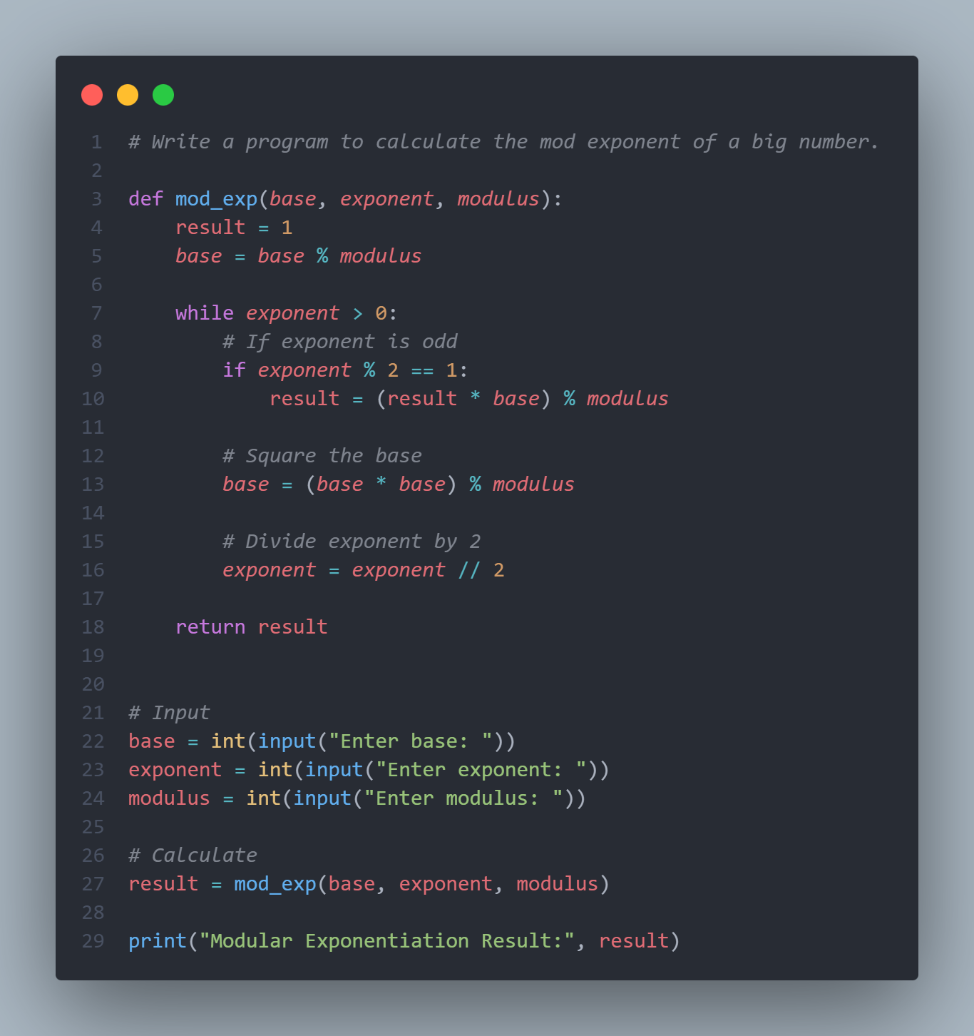

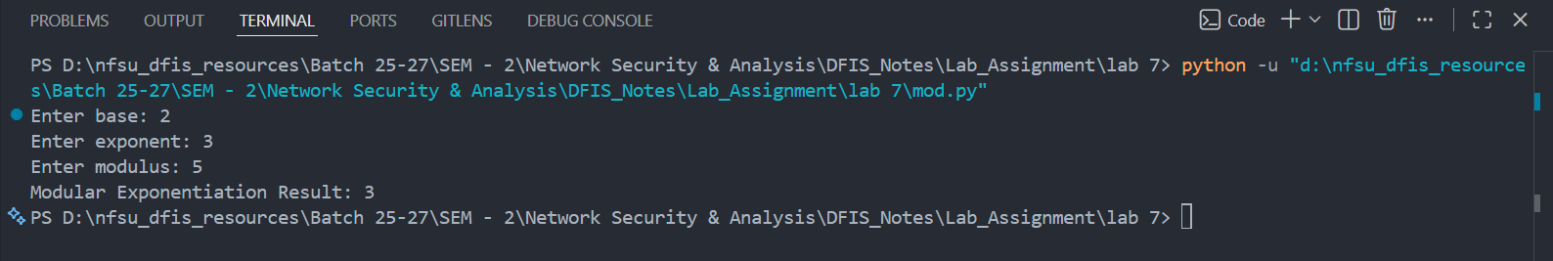
Write a program to demonstrate RSA algorithm by taking input plaintext from a file and produce outfile into ciphertext file.
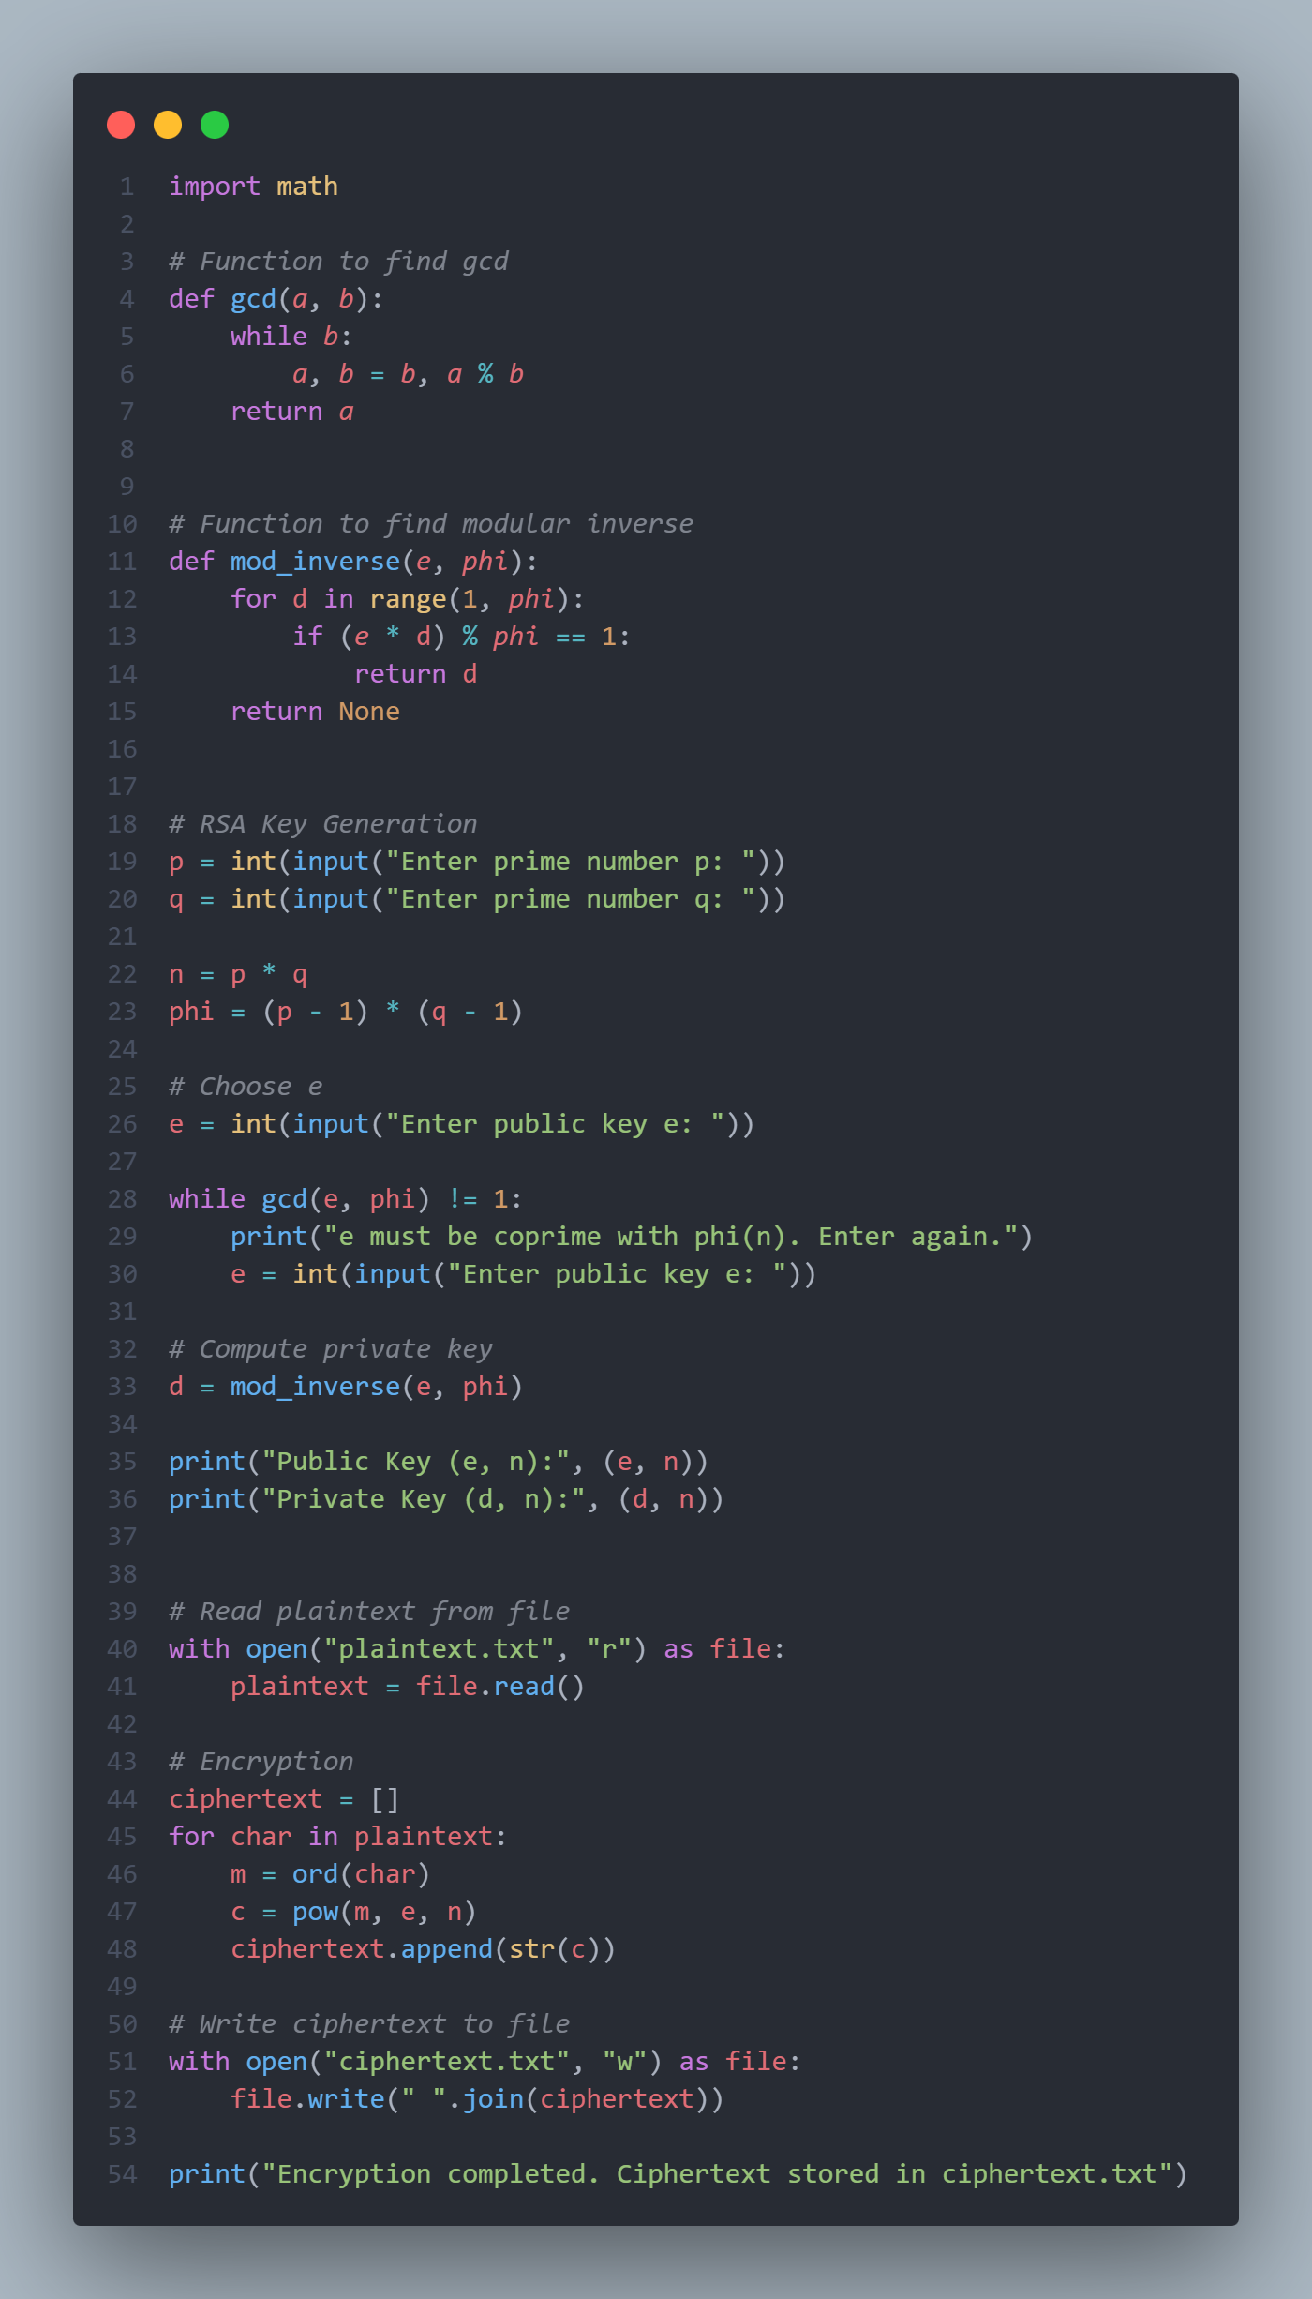
Output
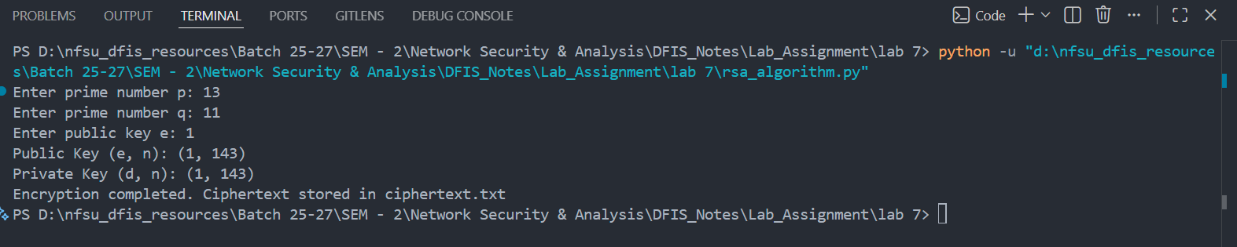

Write a program to implement Fermit Little Theorem.
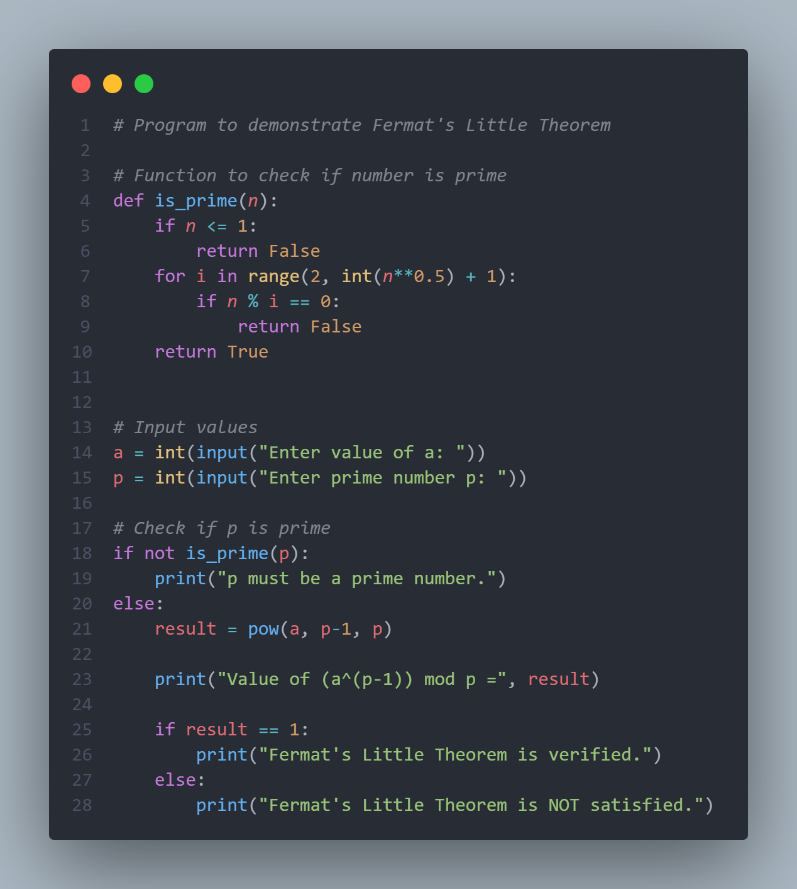

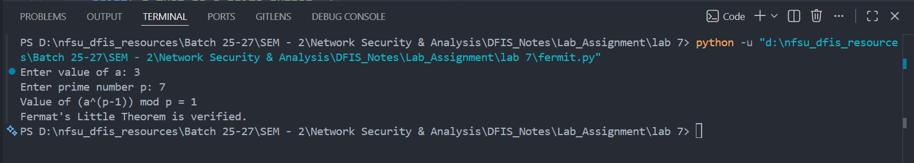

Name: Varia Neel Jitesh
Enrollment No: 250447003019

Network Security And Forensics
Lab Session – 7A
Program 1:WAP to demonstrate RSA algorithm.
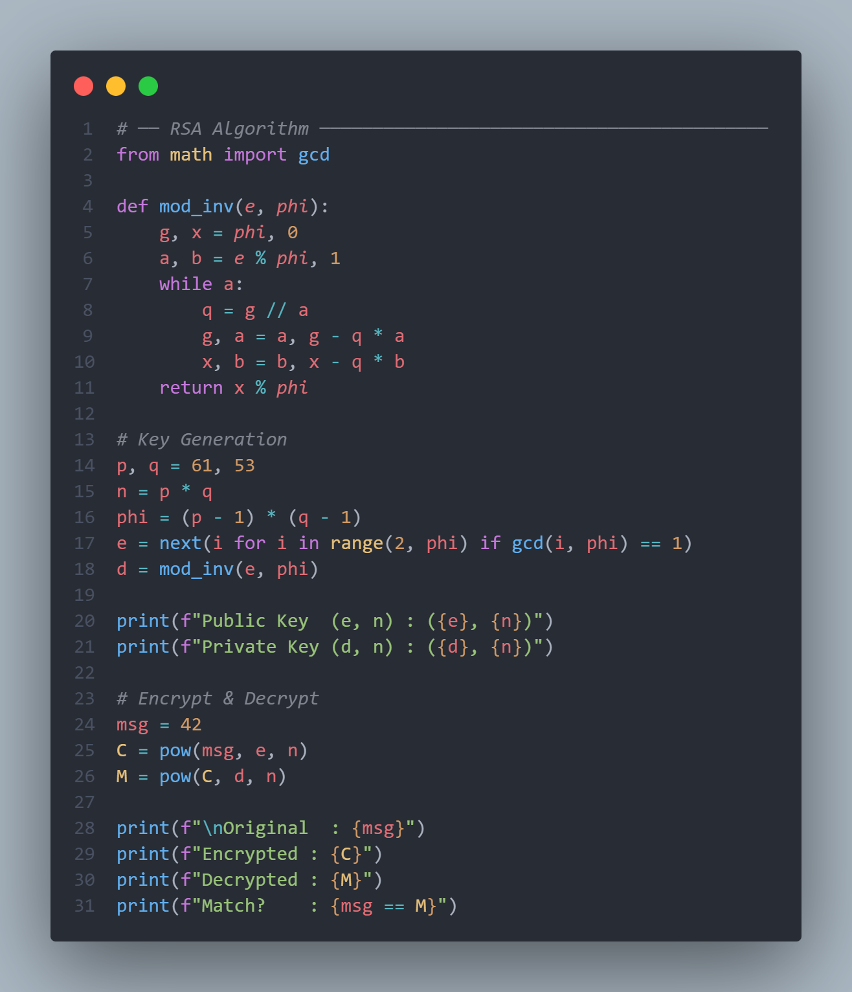

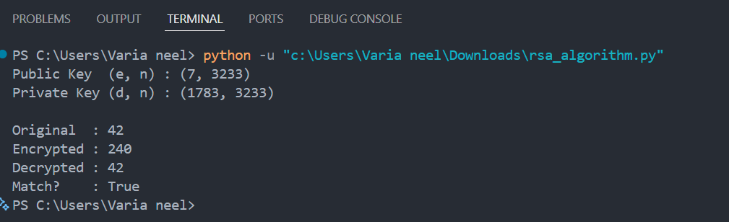

Program 2: WAP to demonstrate Diffie Hellman cryptosystem.
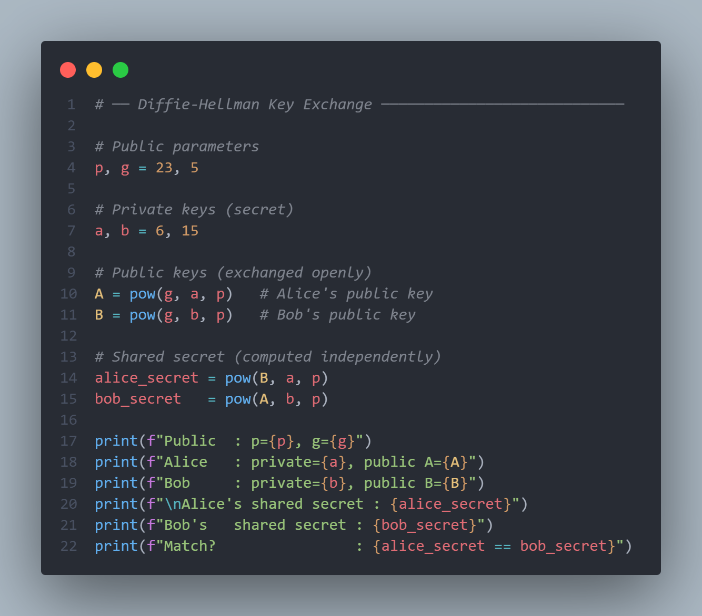

Output
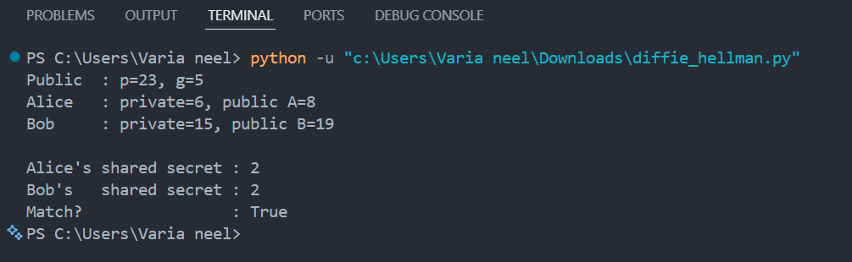
Program 3: WAP to demonstrate ECC cryptosystem.
